Meredith Kress
IMS 452 – Thesis

I am a senior at Miami University and completed my senior thesis this semester as a student in the Interactive Media Studies program. The start of the semester was a little overwhelming when I was basically told the world is my oyster. With endless opportunities, I went about answering the questions of what problems I wanted to solve while keeping my interests, values, and aspirations in mind. As a graphic design minor, I knew I wanted to simultaneously embark on a stellar thesis while also improving my portfolio. The question I went about answering was how do we encourage hand written mail and simplify the shopping experience while still keeping an element of surprise?

Abstract

Technology is an ever-changing part of our world that continues to improve digital communication and therefore people rely on social media and cell phones to stay connected with friends. Hand written stationary is falling behind the times and the concept that is lacking in the digital world is personalization and customization. Another inhibiting factor is the rise of online shopping and click-to-buy convenience. The combination of online shopping and social media communication needs to be met halfway when it comes to stationary. The goal is to simplify the greeting card shopping experience and make staying connected more personal. This subscription will provide users with an interactive app that follows the users calendar in order to suggest cards for appropriate occasions and creates an address book based on friends you connect with. This solution eliminates sending a late card and having to ask for the receiver’s new address. The incentives are rewards for loyal subscribers and discounts for new members that are referred by friends. The objective is to keep connected on a more personal level when life changes and connections are distanced.

Research

I went about researching the greeting card industry and subscription boxes to understand the market I was aiming to enter. Throughout my research I not only learned about those industries but also what solutions to this problem were already available to consumers. There are many sites for custom stationery and I knew I wanted to avoid that, but it posed as a competitor due to convenience. There is an app called Felt that allows you to write with a digital pen and sends the card for you with no hand written message. There is another app called Postable that has the same process except the message is typed out, again no personalization of actual handwriting. I knew that this was the key element to my idea that set it apart from competition. This generation’s reliance on social media to connect and build relationships may be convenient but it is a crutch to valuable connections over distance.

Reviewers

I had started with two reviewers that turned into checking in with a bunch of different people whom I valued their opinions. One of my reviewers was Lauren Mitro, a recent Miami graduate, architect, designer, artist, and honest friend. As a recent graduate, she was on the young end of my target audience. My other reviewer, Karen Carbone, a fourth grade teacher, consistent card-writer, new mom, and subscription box fan. She was the hyperactive person in my target audience. Their insight was valuable to me as I could turn to them for their outsider opinion on the designs, concept, and user experience.

Demo 1

Moving forward from research, I started sketching out stationery that could be sold by Cross & Dot. Coming up with the name was a process of writing down words associated with writing, stationery, and connections. I thought I was so clever when I came up with the name and it was a spark in the process that made me think this project was really going somewhere. It was hard to see into the future and wrap my head around being in love with a project for a whole semester, but this really became something I woke up wanting to work on.

When working on content to present for demo 1, I wanted to have a presentation that gave my classmates a clear vision of where I was headed while also making the pitch seem needed. I included the initial logo, color scheme, and fonts I had come up with. With the insight from my reviewers and my research, I came up with two personas. One of which buys a pack of stationery and occasionally sends cards for birthdays and thank-you notes and would buy 5+ cards at a time. The other persona buys cards per occasion and sends 2-4 a month and would try the product on a monthly basis.

For Demo 1 I pitched two potential business models
Process 1
- Get the app and sync your calendar
- Get notifications of events you could buy a card for
- Pick 5 cards and select from your address book who will be receiving them
- Place your order
- Receive the cards – pre-addressed and stamped
- Handwrite note
- Put in your mailbox
Process 2
- Pick your subscription level/commitment
- Get X amount of cards a month
- Select who you want to get in touch with from address book
- Get the card
- Handwrite note
- Put in your mailbox

As for the stationery designs, they were arranged in sets. I then had 8 app screens for mockups. These included a login and registration page, a menu, shopping page, address book, and calendar. From there I saw myself moving forward with contacting an artist to feature, finalizing more of my own designs, working on pricing, and testing the app.

Demo 2

The concept of featured artist was important to me and felt like a valuable aspect to the business model. I love learning about other artists and collaboration is a great way to market Cross & Dot. I got in contact with Julianne Strom Brill of Moss and Blue through my mom who had worked at the same school as her. In reply to the first email, Julianne was thrilled with the idea to make stationery for Cross & Dot as she had never even explored the stationery medium before. She was also a great resource in providing feedback about my concept pitch and also mentioned connecting me with other artists she knew. With an entrepreneur’s stamp of approval, I truly saw this becoming a real business.

When Julianne went about ordering prints of her paintings, she found that Vista Print allows you to buy 10 of the same card in an order so she had to buy ten sets of ten different prints in order to put her packages together. Knowing this, I then looked at pricing to estimate what I would spend to launch Cross & Dot. With that said, I found that the best solution would be to test out a handful of the best designs to see how those work and run with the overall business plan and app before committing to multiples of every print. I went with Vista Print after exploring competitors like Shutterfly and Minted because it is easy to upload your own designs without a suggested frame or format, they had the best pricing, and they were quick to ship Julianne her designs.

For the second presentation, I had better refined the Cross & Dot process to the calendar sync notifying you of card worthy events. The user would then select as many cards as they wanted and whom they were going to. The cards would be sent out and all that had to be done was the written letter. Following this refinement, I wanted to better adjust to scope. I conducted a survey asking about consumer’s calendars, card-buying experiences and frequencies, and card spending. The results to this survey were not very insightful, as I did not reach a large enough audience. The feedback did confirm the mainly female demographic for card buying, a high interest in subscription services, and a resounding interest in Cross & Dot.

Reviewer’s comments
I had asked Lauren to be another featured artist, as I have seen her work and her talent having had class with. She had sent me designs and I don’t think she knew the level of creativity I was looking for. When I sent her pictures of what Julianne had created, she got a better idea of what I was looking for and was going to work on new designs. Life got in the way, but if Cross & Dot progresses I would contact her as a client.

Karen liked where the project was headed, but still felt that the process needed some refinement in order to be more concrete.

App Development
I had been working in Sketch on my app designs and after the first demo, I knew I wanted to stick with the color scheme but I wanted to make the buttons and functions more realistic. I created a bottom navigation bar and looking into existing apps that had similar interfaces to what I pictured for Cross & Dot assisted me in knowing how to improve and what screens to add.

Moving forward, I set out to add more pages to my app, make a marketing plan, and design more print options. I felt that I was in a good place moving to the final presentation after meeting with Artie one on one a couple of times to reassure that I was on track.

Final Presentation

For the final presentation I had polished up my app mockups and had 14 final screens. I did not simulate the buttons functions as I had for the original demo because it was not necessary. I presented the ordering process the same as I had before, but post feedback from the presentation, I have finally landed on the concrete business plan. I presented this info graphic to communicate the Cross & Dot system.

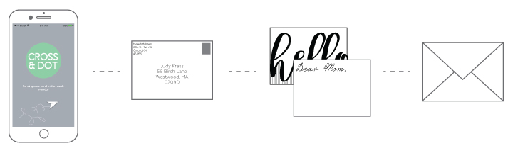

The final sequence I landed on goes as follows: At the end of each month Cross & Dot will notify you as to what card-worthy events you have coming up for the following month and is a subscription based on 5 cards a month/$10. Place your order by the 25th and your package of cards for the following month will arrive on the first. For example:

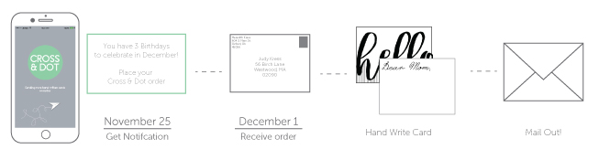

If you need more cards that month, your fee will change accordingly and if you don’t need cards for that month, you can skip it for the next month. Then the rest of the process continues as it had been. By changing to a subscription, my mission of encouraging people to write more hand written stationery is encouraged for not only existing events, but also for customers to write for the purpose of more personal connections.

Next up

I plan to execute the marketing plan and network in order to see what the potential is of Cross & Dot. I am taking an app development class next semester and hope to transition from mockups to a real app.

